**Transitional Justice and Postconflict Reconstruction in Somalia: The Role of the African Union and Pointers Provided by It**

The devastations of conflict and the continuous struggles to “resuscitate” Somali formal institutions seem to expose both the fault lines in post-independence nation building on the one hand and their tendency to generate disorder on the other. Thus far, much of the political imagining in Somalia constitutes a recitation of abandoned promises.

It is imperative to note that the African Union’s transitional justice framework is yet to be fully constituted. The genesis of the African Union position lies in the Consultation Report abstracted from the African Union Commission Consultation with African Union Member States on Transitional Justice.

One of the main themes of the African Union Consultation Report is the strong case it makes for the co-optation of traditional mechanisms into transitional justice processes. The idea of tapping into local capacities to promote and consolidate peace as well as foster justice has become an increasingly fashionable one.

This proximate interface with communities allows the xeer system to claim a duality of functions, which, though appearing to privilege restorative justice by seeking to restore social order, nonetheless performs critical roles in peacebuilding.

despite the dominance of the adversarial dimension of transitional justice, lineage social governance through the xeer system appears more suited to Somalia. The xeer’s long history and attributes of acceptance and legitimacy make it amenable to Somali society.

As suggested above, the internalization of transitional justice processes in Somalia must not be dependent on the end of conflict. Peace ought to be both a means and an outcome. In the xeer, there is the social infrastructure to help in both the attainment of peace and the enforcement of transitional justice. The utility of the xeer system lies, perhaps, in its ability to serve both as a mechanism for peacebuilding and as a locally manageable framework through which justice could be enforced.

Social history illustrates that the xeer constitutes an important aspect of Somali society, and its entrenchment in the conscience and environment of communities and cultures lends credence to its functional durability. At least for now, the African Union framework provides a principled basis for the legitimation of traditional social governance as a possible alternative to the dominance of adversarial transitional justice.

_________

**A Model of Transitional Justice for Somalia: Margherita Zuin**

* · Somalia’s population is a rare example of relative homogeneity in Africa; Somalis possess a common language (Somali) and religion (Sunni Muslim) as well as a complex history.
* · As the history of Somalia demonstrates, clanship is a central form of political organization and identification for Somali people.26 In a situation characterized by deep insecurity, clans have guaranteed the support and protection of their members and provided balance and security.27 Moreover, the government and the most pow- erful clans have discriminated against and marginalized ethnic minorities with dif- ferent languages and clan histories, which caused them to be excluded from access to positions of political power.28
* · Despite the lack of a functioning government, local structures within Somali society have served to maintain a minimum level of stability, rule of law, and justice. One such structure is the Xeer, a dispute settlement mechanism based on clan/family cus- tomary law and elements of Sharia law, the body of law derived from the Koran and from the teaching and examples of the Prophet Mohammed. The Xeer system is still the most commonly used and reinforced justice mechanism.
* · The clan elders, acting as judges, lead Xeer processes. In some cases, the clan elders belong to the disputing clans, in other cases they belong to third-party clans. The Xeer is an unwritten agreement created bilaterally between two clans.
* · The Xeer system is associated with the idea of restorative justice. One of its main goals is to reestablish the social order. Victims are compensated through a Diya (blood compensation), which consists of either money or livestock.40 It also serves to deter further crimes, and to reintegrate both victims and perpetrators in their com- munities.
* · A series of features that characterize the Xeer make the system particularly suitable for Somalia, because of the traditional and cultural issues. It is also practical: the system is already in place, so no major new structures are needed, such as the construction of courts and the election of judges. Additionally, the financial resources necessary to implement this mechanism are minimal. In that regard, international and hybrid tribunals are less suitable for Somalia because they require significant resources for their creation and their functioning.
* · Local systems developed according to Somali culture have a better chance of surviving the prevailing chaos. In addition, leveraging the traditional system will serve to legitimize and increase recognition for such local practices.
* · The formal justice system is often corrupt and biased and it is commonly controlled by the most powerful groups. It therefore lacks legitimacy in the eyes of the wider population.
* · Another benefit of the informal system is accessibility: for people living in rural areas, formal tribunals are largely inaccessible, whereas the informal system is viable given its localized nature.
* · Beyond its perceived legitimacy, the Xeer is more enforceable because social pressure often compels compliance to judgments. The imperative to respect the de- cisions also derives from a collective recognition of the necessity to avoid an escala- tion of violence and revenge among clans.
* · The analysis described above suggests that the newly elected Somali government should support the implementation of the Xeer system as a transitional justice mecha- nism. This will invest the Xeer with the legitimacy derived from not only customary practice, but also from formal authorities.
* · the Xeer system has the potential to reinforce old power structures and perpetrate discrimination against the less powerful clans and minority groups. the prohibition against women’s participation in Xeer justice is deeply problematic.
* · The second mechanism that holds potential to bring justice in Somalia is an ad hoc tribunal (either international or hybrid). Staffed with both international and national employees, an ad hoc hybrid tribunal would be ideal given that it would be located in Somalia. This would keep justice proceedings close to the victims and increase the sense of Somali ownership over the transitional justice process.
* · The first goal of the ad hoc tribunal would have to be accountability: to hold perpetrators responsible for their conduct, through public acknowledgement of the criminal responsibility for violations of human rights and humanitarian law. A second goal is deterrence, both in Somalia and internationally.
* · Regardless of the type of ad hoc tribunal, an important issue to resolve early on is that of temporal jurisdiction, the period of time within which crimes were committed over which a court has jurisdiction. In the case of the ad hoc tribunal for Somalia, the temporal jurisdiction of the tribunal should cover the entire duration of the war.
* After a protracted conflict where war crimes and crimes against humanity are committed, a mechanism for retributive justice is necessary to ensure that the perpetrators do not go unpunished. The general sentiment among the international community supports this imperative, as reflected in the common conclusion that crimes against humanity affect humanity as a whole.
* Maintaining that justice serves both retributive and restorative goals, this article proposed two mechanisms answering the respective goals: the tra- ditional justice system (Xeer) and an ad hoc tribunal.

**Challenges for a future reintegration programme in Somalia: outcomes of an assessment on drug abuse, psychological distress and preferences for reintegration assistance**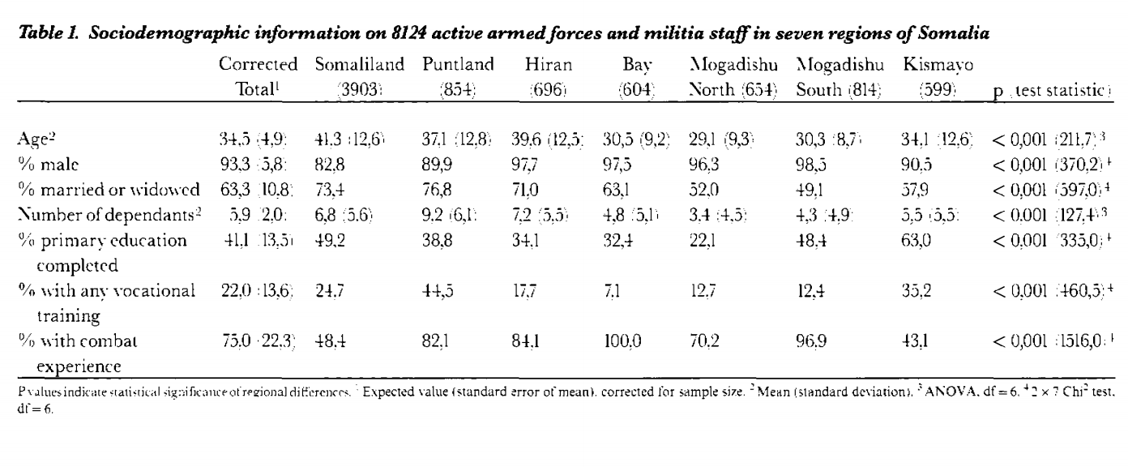

Three groups who need special reintegration assistance: those with unrealistic expectations of monetary support, those with psychological problems and/or a return to formal education, and respondents at risk of developing chronic psychological disorders.

**Somalia--Painful Road to Reconciliation**

Then, in August 1990, the SNM joined forces with two other recently formed opposition groups, the Ogadeni-based Somali Patriotic Movement (SPM) and the Hawiye-based United Somali Congress (USC). It was this alliance which ousted Barre in January 1991. The USC's hasty announcement of Ali Mahdi as the interim president resulted in an immediate split of the USC along sub-clan lines. The Habar Gedir-based faction, led by General Mohammed Farah Aideed and the Abgal- based group led by Ali Mahdi thus began a brutal intra-clan struggle for power.

Most third party interveners have seriously erred, bee-lining straight to the source of the problem (warlords), while neglecting to see other potentially influential actors who would likely be part of the solution. Since only 5 percent of the Somali population has been involved in the perpetration of violence, it was a dire mistake to solely focus reconciliation efforts around them.

In Somalia, a few insightful mediators, namely chief UN envoy Mohamed Sahnoun and US special envoy Robert Oakley, realized the inefficacy of top-down reconciliation. Perceiving the need for a broader-based regeneration of civil society, these mediators sought to empower local leaders and prominent citizens. Broadening the scope of actors has enabled Somalis to begin taking control of the process of rehabilitation and reconciliation.

The initial post-Barre conflict concentrated largely upon issues of territory and power. While the struggles for land and power continued, the looting of relief shipments came to constitute a third focus of the struggle.

* Placing these issues of clan conflict in broader perspective, the irony of clan power struggles becomes apparent. These clan groups are not fighting over ideology, religion, values or any other fundamentally substantive bones of contention. They are primarily fighting over power. The civil war has totally destroyed the country; the economy has been utterly decimated and there is little left to fight for

For the victors there will be no spoils, but rather the arduous and difficult tasks of rehabilitation: comprehensively rebuilding the country from the bottom up. This will be less a position of privilege and perks, than one of base-level nation-building and reconciliation. Somalia's rehabilitation process will be a slow and cumbersome one; the most pressing issue at the moment is to determine who is capable of guiding the process.

“The West's "carrot and stick" strategy alone might not have resulted in serious negotiations had it not been for the tireless efforts of chief UN envoy Mohamed Sahnoun and US special envoy Robert Oakley. These two men contributed significantly to the broadening of the definitions of "actor" in the Somali conflict. Refusing to restrict their efforts to the warlords who have essentially caused these problems, Sahnoun and Oakley insisted on the inclusion of other prominent groups as a critical component of an organic, Somali-focused solution. These mediators met often with Aideed, Mahdi and other clan leaders, but also met regularly with women, clan elders, religious leaders, and intellectuals. Donatella Lorch reported that Oakley 'believes the Americans' greatest success has been in reducing the power of the warlords and bringing into the peace negotiations everyone from elders to intellectuals to women.”

The Somali case bears particularly important lessons for those interested in the evolving role of the UN. The organization's new role will be one in which peace-keeping activities will need to be balanced by equal dedication to peace-making and peace-building efforts.' Additionally, a broader mandate systematizing proactive and preventive interventions should be instituted. Care must be taken to ensure universalist solutions are not imposed from above, but rather are context-appropriate. When defining the conflict "actors", the international community should lend legitimacy to larger segments of civil society; this will give reconciliation processes more momentum and enhance the likelihood that solutions will be durable.'